**S-52 updated for IMO S-100 ECDIS Performance Standard MSC.530(106)**

**10.5.9 Detection and Notification of Navigational Hazards**

The IMO Performance Standard for ECDIS MSC.530(106), clause 11.3.5 Route planning states;

*11.3.5 A graphical indication should also be given if the mariner plans a route closer than a user-specified distance from a user-selectable category of point objects, such as a fixed or floating aid to navigation or isolated danger. The user-selectable categories should be the same as the user selections for the display of objects and be based on IHO standards. There should be a permanent indication when any user-selectable categories are deselected. Details of the deselection should be available on demand.*

Clause 11.4.6 Route monitoring states;

*11.4.6 ECDIS should give a warning or caution or indication as selected by the mariner and related graphical indication if, continuing on its present course and speed, over a specified time or distance set by the mariner, own ship will pass closer than a user-specified distance from a user-selectable category of danger (e.g. obstruction, wreck, rock) that is shallower than the mariner's safety contour or a user-selectable category of aid to navigation. The user-selectable categories should be the same as user selections for the display of objects and be based on IHO standards. There should be a permanent indication when any of the user-selectable categories are deselected. Details of the deselection should be available on demand.*

The following table lists the S-57 objects and their attributes that satisfy the conditions above and must precipitate an indication within the ECDIS. The point, line or areas must be graphically indicated using the instructions contained in the lookup tables named “indhlt”. “indhlt” is not an ENC charted object class, but an object that must be created by the ECDIS. See Fig 7 for example.

|  |  |  |
| --- | --- | --- |
| **S-57 Objects** | **Condition (if any)** | **Geometric primitive** |
| BCNCAR |  | POINT |
| BCNISD |  | POINT |
| BCNLAT |  | POINT |
| BCNSAW |  | POINT |
| BCNSPP |  | POINT |
| BOYCAR |  | POINT |
| BOYINB |  | POINT |
| BOYISD |  | POINT |
| BOYLAT |  | POINT |
| BOYSAW |  | POINT |
| BOYSPP |  | POINT |
| BRIDGE |  | POINT, LINE, AREA |
| CBLOHD |  | LINE |
| DAYMAR |  | POINT |
| PIPOHD |  | LINE |
| CONVYR |  | LINE, AREA |
| MORFAC |  | POINT, LINE, AREA |
| NEWOBJ | CLSNAM = Virtual AtoN, * | POINT |
| FSHFAC |  | POINT, LINE, AREA |
| ICEARE |  | AREA |
| LITFLT |  | POINT |
| LITVES |  | POINT |
| LOGPON |  | POINT, AREA |
| OFSPLF |  | POINT, AREA |
| OILBAR |  | LINE |
| PILPNT |  | POINT |
| PYLONS |  | POINT, AREA |
| OBSTRN | **DEPTH_VALUE < = safety contour value | POINT, LINE, AREA |
| UWTROC | DEPTH_VALUE < = safety contour value | POINT |
| WRECKS | DEPTH_VALUE < = safety contour value | POINT, AREA |
| SOUNDG | EXPSOU=2 and VE3D subfield< = safety contour value | POINT |
|  |  |  |

*Denotes that all New Objects with the object class name pre-fix ‘Virtual AtoN’ must be indicated.

** DEPTH_VALUE is not an S-57 attribute, it is derived from CSP OBSTRNnn and WRECKSnn. The safety contour value is set by the user. Objects not passing through the CSP are not part of Detection and Notification of Navigational Hazards

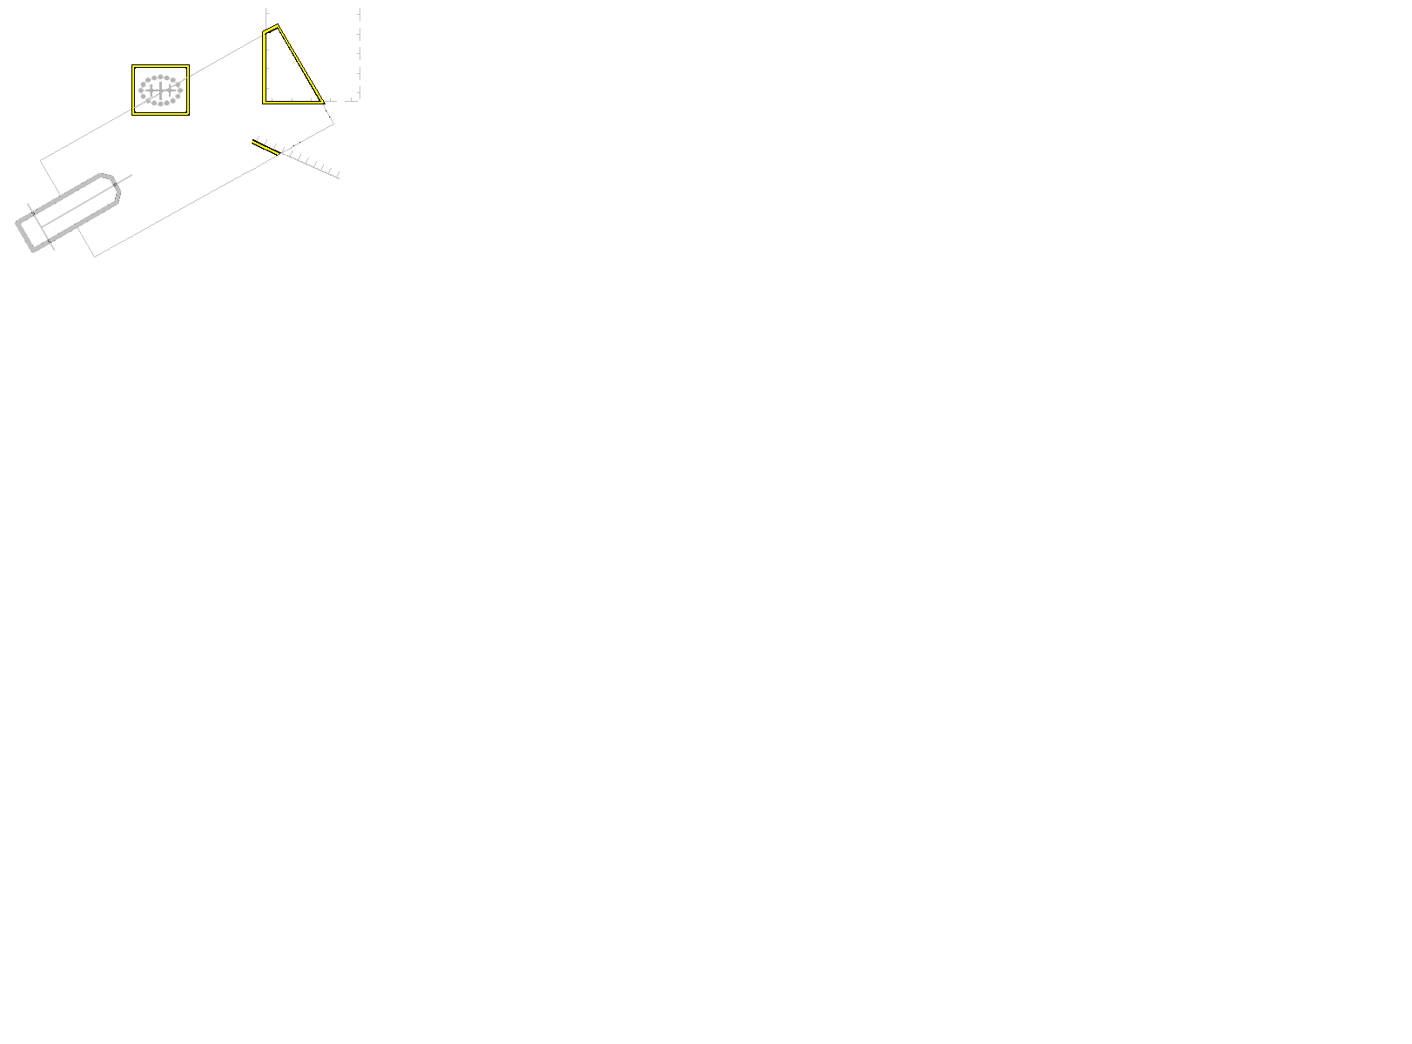

**Fig 7. Example of indication highlighting ECDIS described in 10.5.9 and 10.5.10**

**10.5.10 Detection of Areas, for which Special Conditions Exist.**

The IMO Performance Standard for ECDIS MSC.530(106), clause 11.3.5 Route Planning states;

*11.3.5 A graphical indication should be given if the mariner plans a route closer than a user-specified distance from the boundary of a user-selectable category of prohibited area or geographic area for which special conditions exist (see appendix 4).*

Clause 11.4.4 Route Monitoring states;

*11.4.4 ECDIS should give a warning or caution, or indication, as selected by the mariner, and related graphical indication if, within a specified time or distance set by the mariner, own ship will pass closer than a user-selected distance from the boundary of a user-selectable category of prohibited area or of a geographical area for which special conditions exist (see appendix 4). The user-selectable categories should be the same as user selections for the display of objects and be based on IHO standards. There should be a permanent indication when any user-selectable categories are deselected. Details of the deselection should be available on demand.*

The IMO Performance Standard, Appendix 4, specifies the following areas which ECDIS must detect and provide an alert or indication.

* Traffic separation zone
* Inshore traffic zone
* Restricted area
* Caution area
* Offshore production area
* Areas to be avoided
* User defined areas to be avoided
* Military practice area
* Seaplane landing area
* Submarine transit lane
* Anchorage area
* Marine farm/aquaculture
* Particularly sensitive sea area (PSSA)

The following table provides an authoritative mapping between the areas identified within the IMO Performance standard for ECDIS and S-57 feature objects, their attributes and geometric primitives. The point, line or area features must be graphically indicated using the presentation named as “indhlt” in the look-up tables.

|  |  |  |  |
| --- | --- | --- | --- |
| **IMO Special condition** | **S-57 Object** | **Attribute** | **Geometry** |
| Traffic separation zone | TSEZNE |  | AREA |
| Inshore traffic zone | ISTZNE |  | AREA |
| Restricted area | RESARE | RESTRN !=14 and CATREA != 28 | AREA |
| Caution area | CTNARE |  | AREA, POINT |
| Offshore production area | OSPARE |  | AREA |
| Areas to be avoided | RESARE | RESTRN = 14 | AREA |
| User defined areas to be avoided |  |  | AREA |
| Military practice area | MIPARE |  | AREA, POINT |
| Seaplane landing area | SPLARE |  | AREA, POINT |
| Submarine transit lane | SUBTLN |  | AREA |
| Anchorage area | ACHARE |  | AREA, POINT |
| Marine farm/aquaculture | MARCUL |  | AREA, LINE, POINT |
| PSSA (Particularly Sensitive Sea Area) | RESARE | CATREA = 28 | AREA |

**10.5.11 Visualization of the Safety Contour**

The safety contour is defined as an edge between safe and unsafe skin of the earth objects. This edge must be visualized using the presentation below.

**"SAFCON","","LS(SOLD,3,DEPSC)","8","O","DISPLAYBASE","13000"**

**10.5.12 Detection of Safety Contour**

The IMO Performance Standard for ECDIS MSC.530(106), clause 11.3.4 Route Planning states;

*11.3.4 A graphical indication is required if the mariner plans a route closer than a user-specified distance from own ship's safety contour.*

Clause 11.4.3 Route Monitoring states;

11.4.3 It should be possible to select that ECDIS gives an alarm and related graphical indication if, within a specified time or distance set by the mariner, own ship will pass closer than a user-selected distance from the safety contour. There should be a permanent indication of “Safety Contour alarm OFF” when the safety contour alarm is deselected. In accordance with guidance in IEC 62288:2021 4.4.2

The following table specifies the S-57 objects, conditions and geometry that constitute the safety contour and must therefore be used when raising the safety contour alarm.

The point, line or area must be graphically indicated using the presentation named as “dnghlt” in the look-up tables.

|  |  |  |
| --- | --- | --- |
| **S-57 Object** | **Condition** | **Geometry** |
| DEPARE | *DEPARE03 “UNSAFE=TRUE” | AREA |
| DRGARE | *DEPARE03 “UNSAFE=TRUE” | AREA |
| FLODOC | - | LINE, AREA |
| HULKES | - | POINT, AREA |
| LNDARE | - | POINT, LINE, AREA |
| PONTON | - | LINE, AREA |
| UNSARE | - | AREA |
| SLCONS | - | POINT, LINE, AREA |

* DEPARE03 is not an S-57 attribute, it is a CSP.

**Note:** Rocks, Wrecks and Obstructions are in Navigational Hazard Detection.

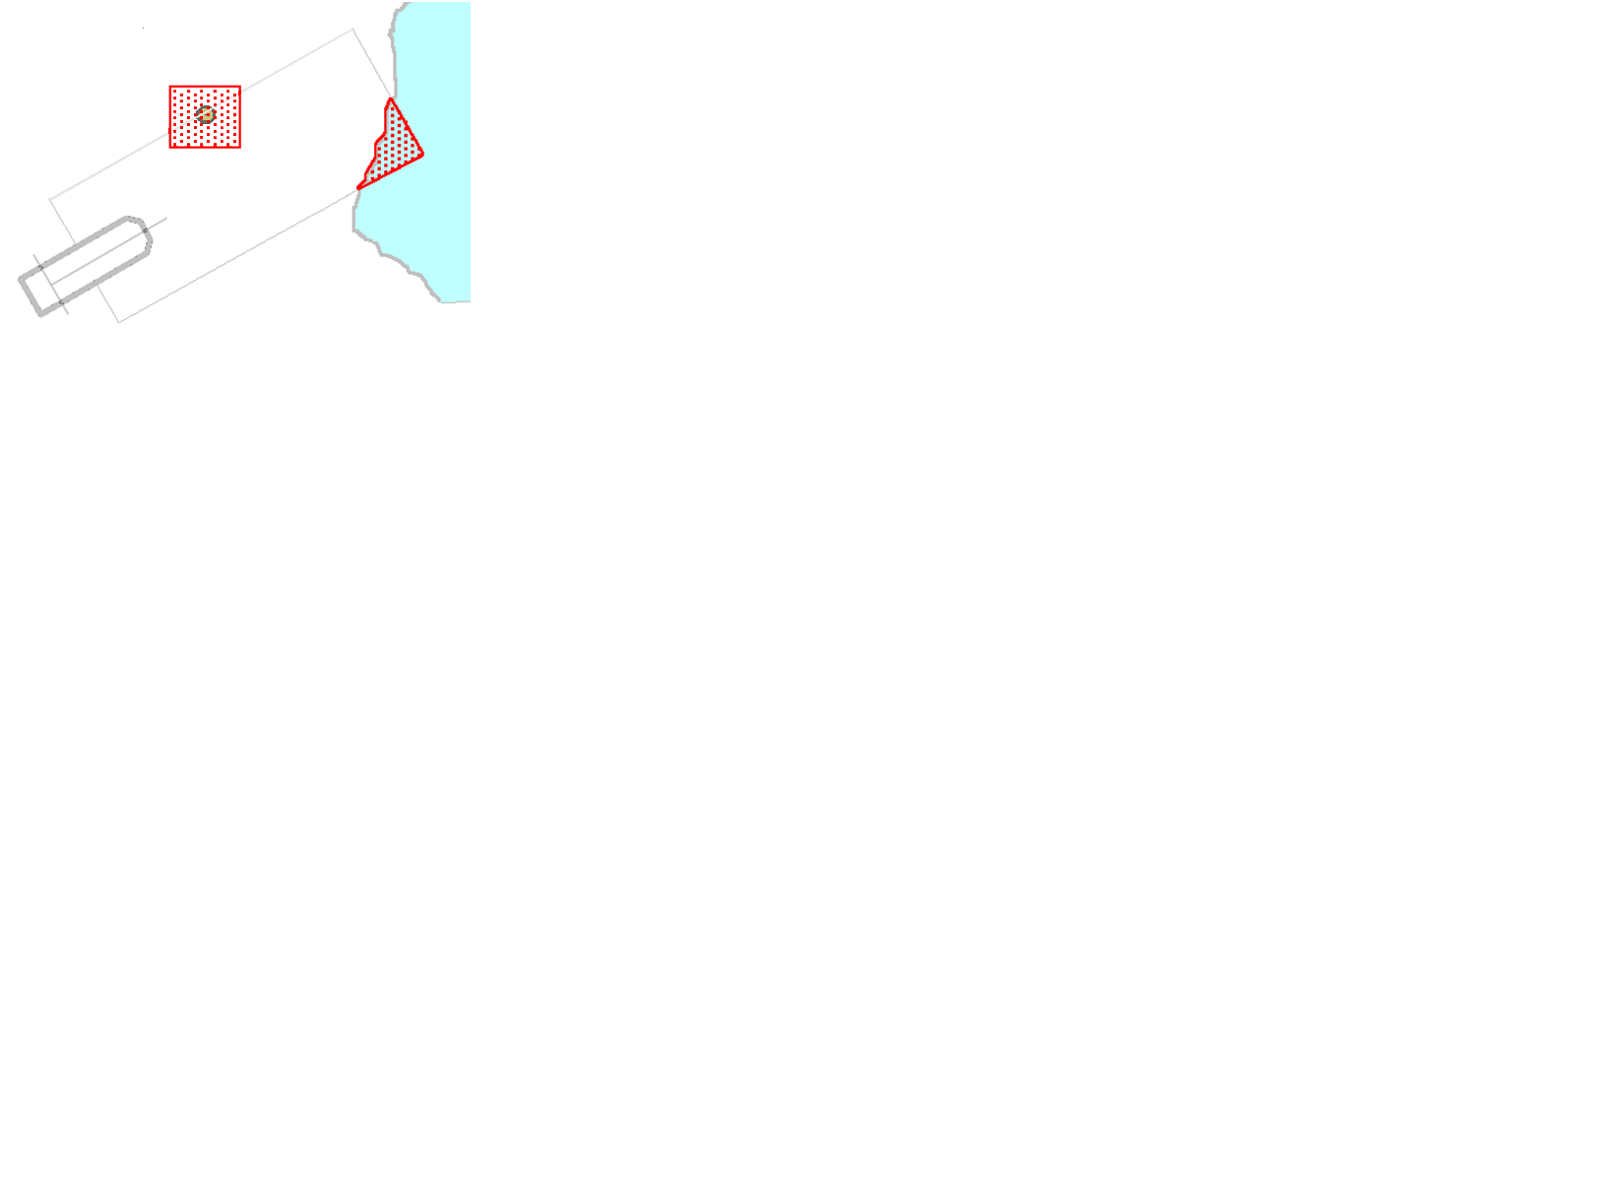

**Fig 8. Example Danger Highlight in ECDIS**

**10.5.13 Indications related to ENC accuracy**

The IMO Performance Standard for ECDIS MSC.530(106), clause 11.3.6 Route Planning states;

*11.3.6 It should be possible for the mariner to select that the indications of 11.3.4 and 11.3.5*

*take into account accuracy information of relevant hydrographic information, as defined by IHO*

*standards.*

Clause 11.4.9 Route Monitoring states;

*11.4.9 It should be possible for the mariner to select that the indications of 11.4.3, 11.4.4, 11.4.6, 11.4.7 and 11.4.8 take into account accuracy information of relevant hydrographic information, as defined by IHO standards.*

When the Mariner has chosen to take accuracy of hydrographic information into account the ECDIS must use the underlying M_QUAL, CATZOC attribute to extend the check area in a horizontal direction for route plans (closer than a user-specified distance) and for own ship (within a specified time or distance set by the mariner, own ship will pass closer than a user-selected distance). The table below specify the amount of the extension in the horizontal direction. For example, if the value of “closer than user specified distance is 100 m and if the value of CATZOC is A2 (20 m) then the check is extended in the horizontal direction up to 120 m.

|  |  |
| --- | --- |
| **M_QUAL – CATZOC Value** | **Positional Accuracy** |
| A1 | 5m |
| A2 | 20m |
| B | 50m |
| C | 500m |
| D | 500m |
| U | 500m |

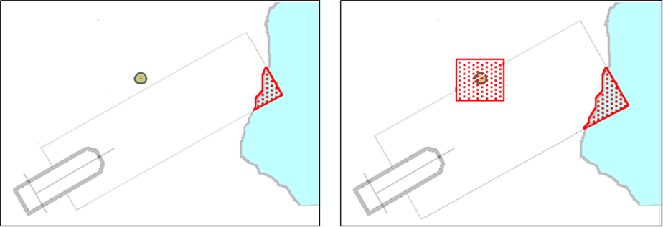

**Fig 9. Example Danger Highlight extended by underlaying value of CATZOC, left is without extension and right is with extension**

When multiple M_QUAL areas with different CATZOC values underlay the check area, then the value of extension changes at the point where the original non-extended check area crosses the boundary of the M_QUAL areas with different CATZOC values, see the example below:

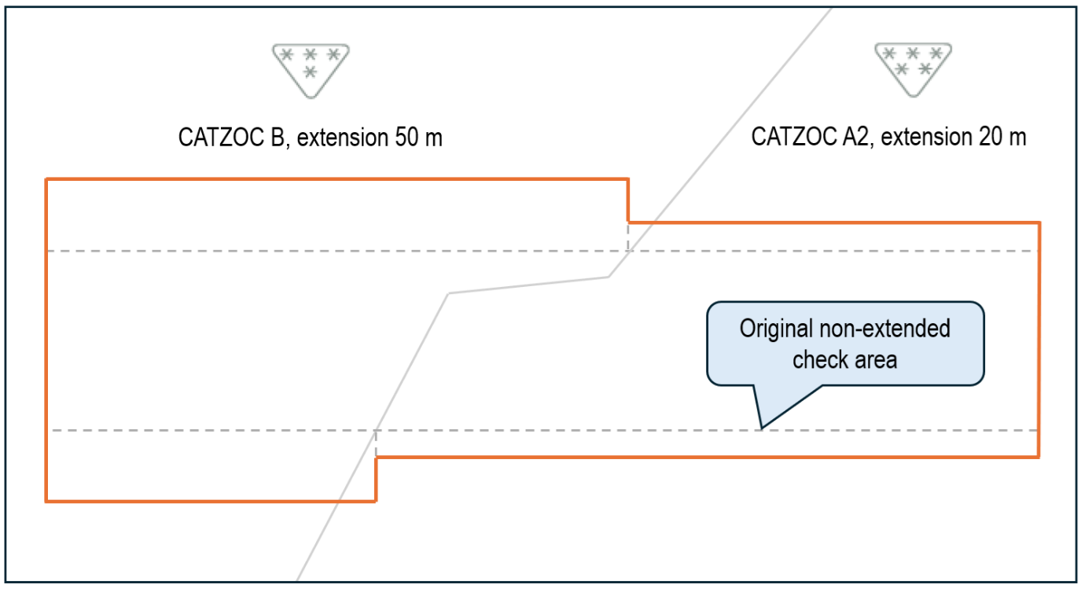

**Fig 10. Example Extension of check-area by multiple underlaying M_QUAL areas with different values of CATZOC**